**Abstract**

As Singapore continues to drive itself as a global maritime hub with more than 130,000 vessel calls annually and being one the world’s busiest transshipment hub, it is important to manage vessel traffic well to ensure that Singapore offers an efficient transit to vessels docking in Singapore (MPA, 2024). Deep learning can help identify types of vessels for Singapore to anticipate demand for these services.

**Introduction**

Singapore offers businesses and shipping lines seamless global trade connectivity, as well as a breadth and range of maritime services that few can match, including bunkering, pilotage, towage, fresh water supply, crew changes and ship supplies (MPA, 2024). Hence, it is essential to understand the various types of vessels docking here in Singapore and anticipating demand so that Singapore can constantly develop our capabilities to deliver to vessel owners and maintaining speed and efficiencies in delivering these services here in Singapore.

The dataset (appendix 1) can be used to train a deep learning model to detect vessel types through deep learning and hence helping Singapore better anticipate vessels type docking at our ports at different season so that Singapore is able to not only develop capabilities to meet these demands at the same time making sure that vessels have a smooth transition to get the desired maritime service that they need to in our hub.

**Dataset/Metadata**

The dataset has 2 columns (Table 1), the first column is the vessel image's file name, and the second is the classification. There are 5 classes, each represented by a categorical value (1 – Cargo, 2 – Military, 3 – Carrier, 4 – Cruise, 5 – Tankers). Table 2 shows the images represented by these categories.

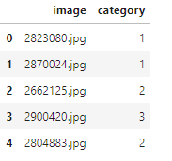

*Table 1: Snippet of dataframe of training data of vessel identification*

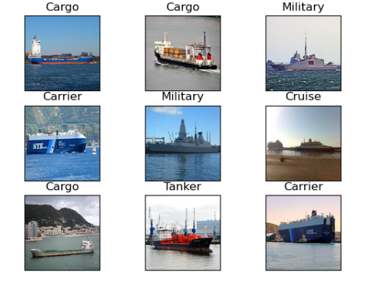

*Table 2: Images representing each vessel type*

**Normalizing of inputs- Scaling**

The data is divided by 255 to normalise the data to convert the data from 0 to 1 so that the numbers will be small and easier to compute which enables the neural network to perform better when fitting and training the model. Table 3 are the results of not scaling the model as compared to Table 2 above after scaling the model.

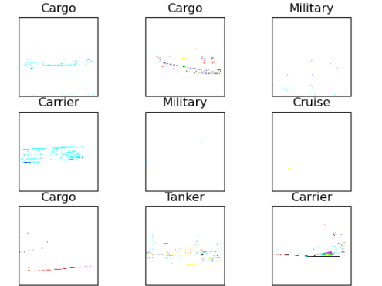

*Table 3: Images without normalising of data*

**Shape of dataset and data pre-processing**

The shape of the dataset has been identified so that it will ease the process of creating parameters when we are building the layers. (Table 4)

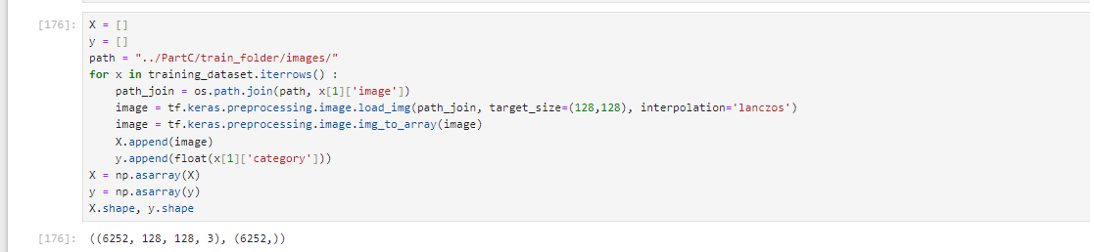

*Table 4: shape of our dataset*

The packages that have been utilized to preprocess our dataset and determine the parameters of our layers is the utils to_categorical package from keras to better help us build the layers with the correct parameters in place(Table 5)



*Table 5: pre-processing of dataset using utils to_categorical library from keras*

**Methodology and model used**

In the deep learning model, the 2-dimensional Convolution Neural network, Max pooling and some layers such as Flatten and drop out are added to the neural model to avoid overfitting and less taxing for the model to process by sampling and downsizing the data volume. These models can be found in python’s Keras model in deployment. Table 6 shows the summary of the layers used in detail.

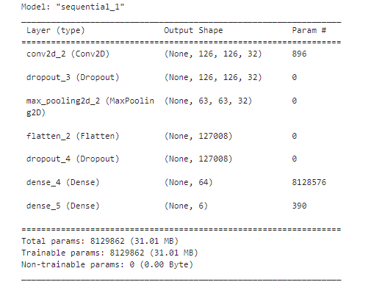

*Table 6: model summary*

**Model evaluation**

After training the model, evaluation was done to ensure that it has high accuracy while ensuring that it does not overfit through identifying the test loss scores. 10 epoch was decided as the optimal number to use as the model already shows promising results from 5 epochs of about 88% accuracy scores, adding additional epoch might increase the model accuracy by marginal value but increasing the chances of overfitting.

## Accuracy scores and test loss

The accuracy obtained from the model is 99% with 6.5% test loss score indicating quite an accurate score in predicting vessel classes

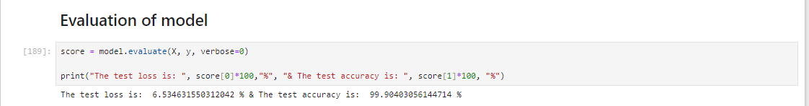

*Table 7 : Accuracy scores and test loss.*

## Confusion Matrix

Based on the confusion matrix (Table 8), the model seems to perform less ideal for class 2 – military classes with a precision of 0.74 and for class 5 with a recall of 0.72 for tankers. It might be due to the number of classes images in the training dataset given for each class giving some of the class lesser data to train on (Table 9).

Apart from the number of images for training, the challenges of these classes predicting accurately consistently will be discussed in the next section but generally the model performs quite decently based on our confusion matrix.

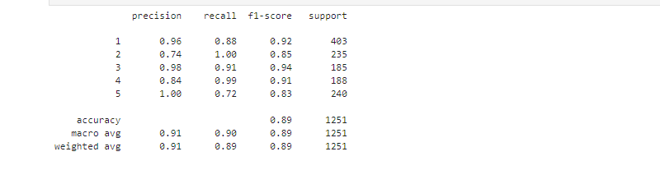

*Table 8: Confusion matrix*

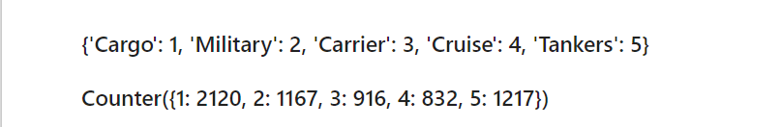

*Table 9: Counter of each class – military, carrier & cruises had lesser images to train on*

**Challenges of the models**

## Image pixels for model predictions

It is very important to take note of the resolution of the photos in pixel form as many online image that can be used need to fit into the square 128 by 128 pixels otherwise it will cause issues in detecting the correct classes in the model and potentially impact the accuracy predictions when images are resized but part of the vessel is being cut off from the process.

## Vessel builds that might change the outlook of a vessel

As discussed previously, Military & Tanker classes perform less ideal than the other class. Hence, in this section we will address some of the challenges in getting these 2 classes perform as well as the other classes. Apart from the number of training datasets for each class, one prime reason might be due to developments in the maritime industry that might potentially influence how each of these vessels will look like in the future.

Increasingly, in the maritime industry we are transiting into new vessel technologies that the industry is leveraging to improve fuel efficiency and hence changing the model of vessels. As the industry is still figuring out on the optimal multi-fuel transition strategies, new build of vessels leveraging on sails, turbines, wind, methanol and ammonia might change the look of vessels making each classes look more differently and might impact on the accuracy of the scores (Picture 1 - new gen Tankers, Picture 2 – new gen military ships), however classes in the cargo space and cruises (Picture 3 - new gen cruise, Picture 4 – new gen cargo ships) look somewhat the same with new technologies. This could be one of the main explanation why some classes such as military and tankers perform slightly low in our deep learning model.

**new**

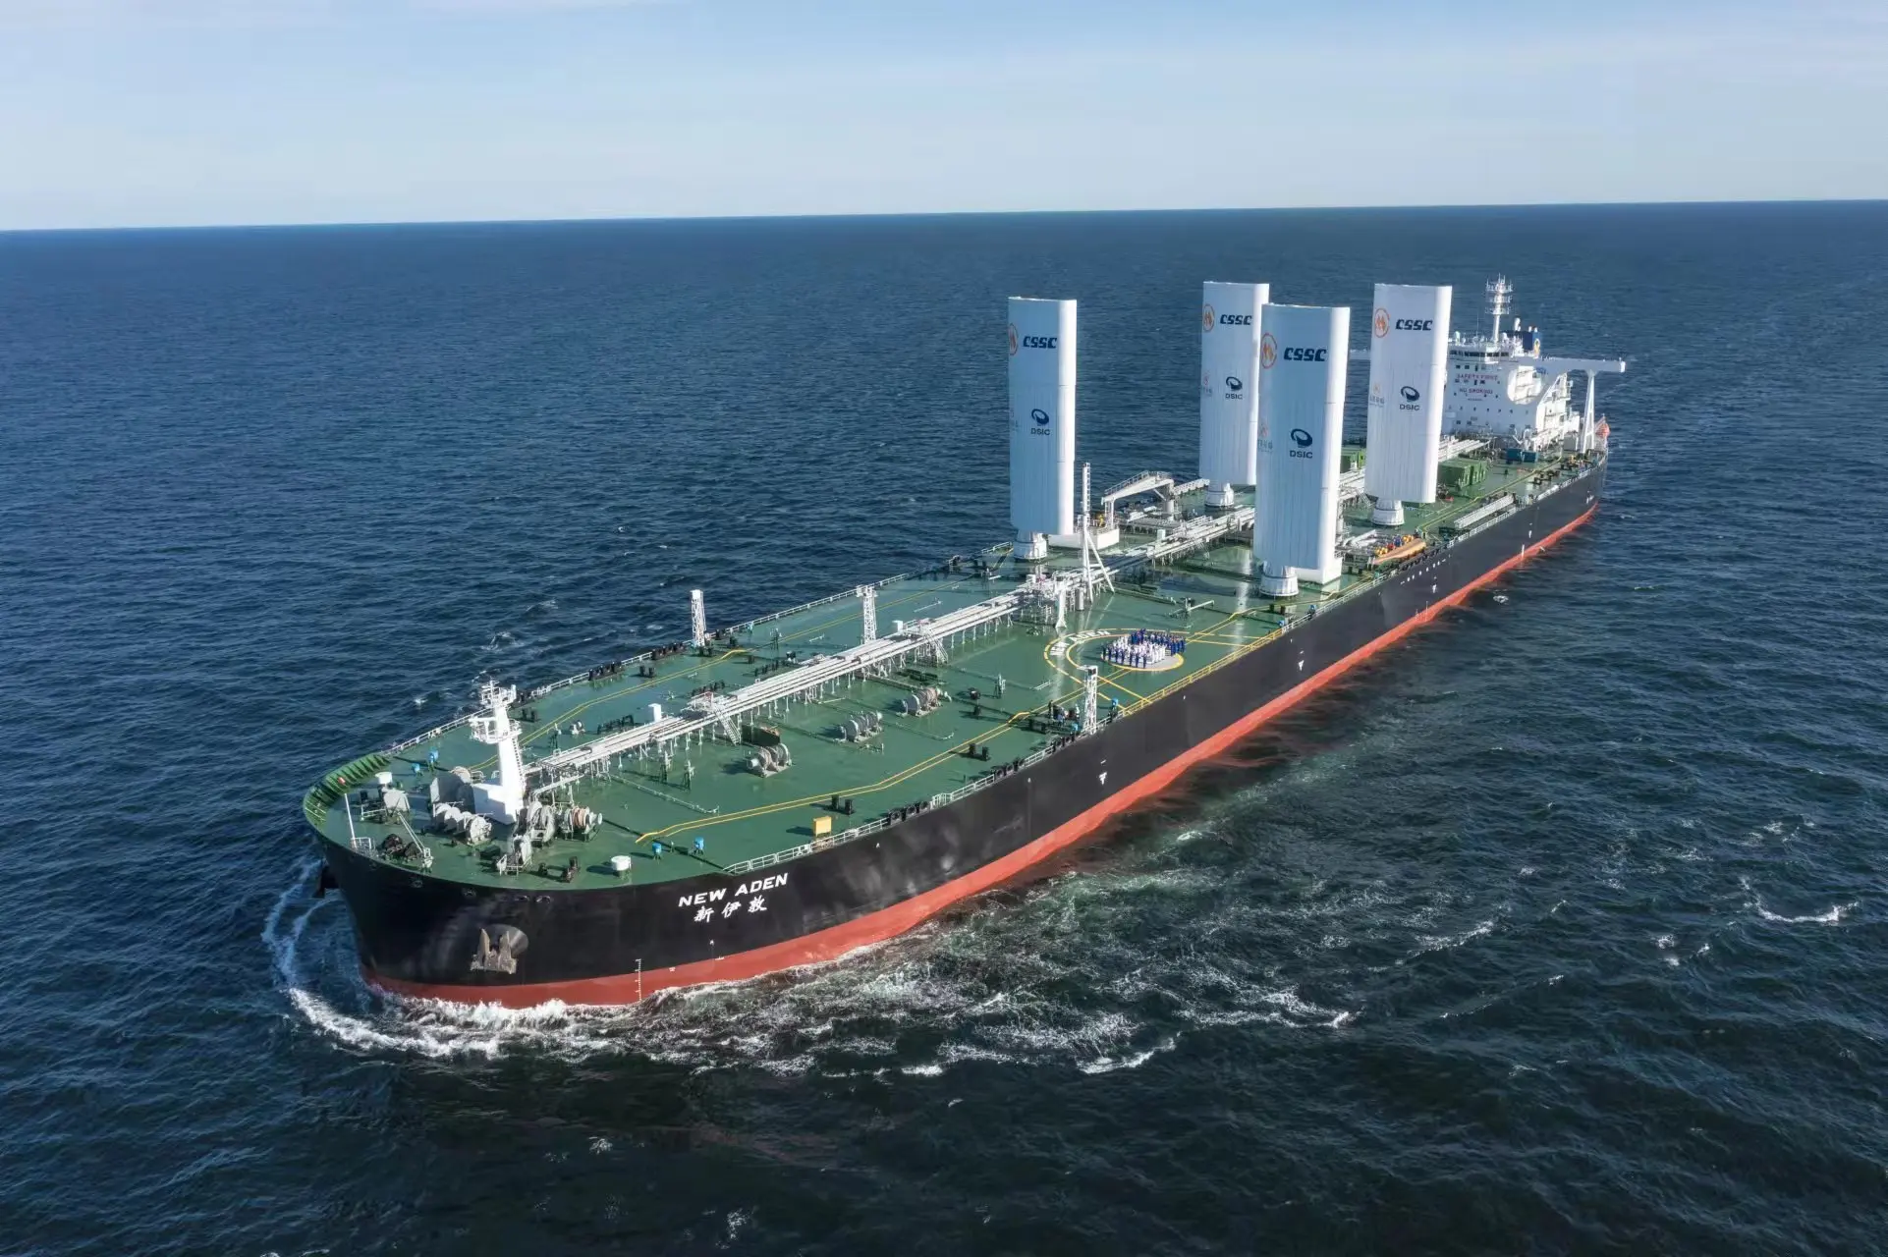

**Old**

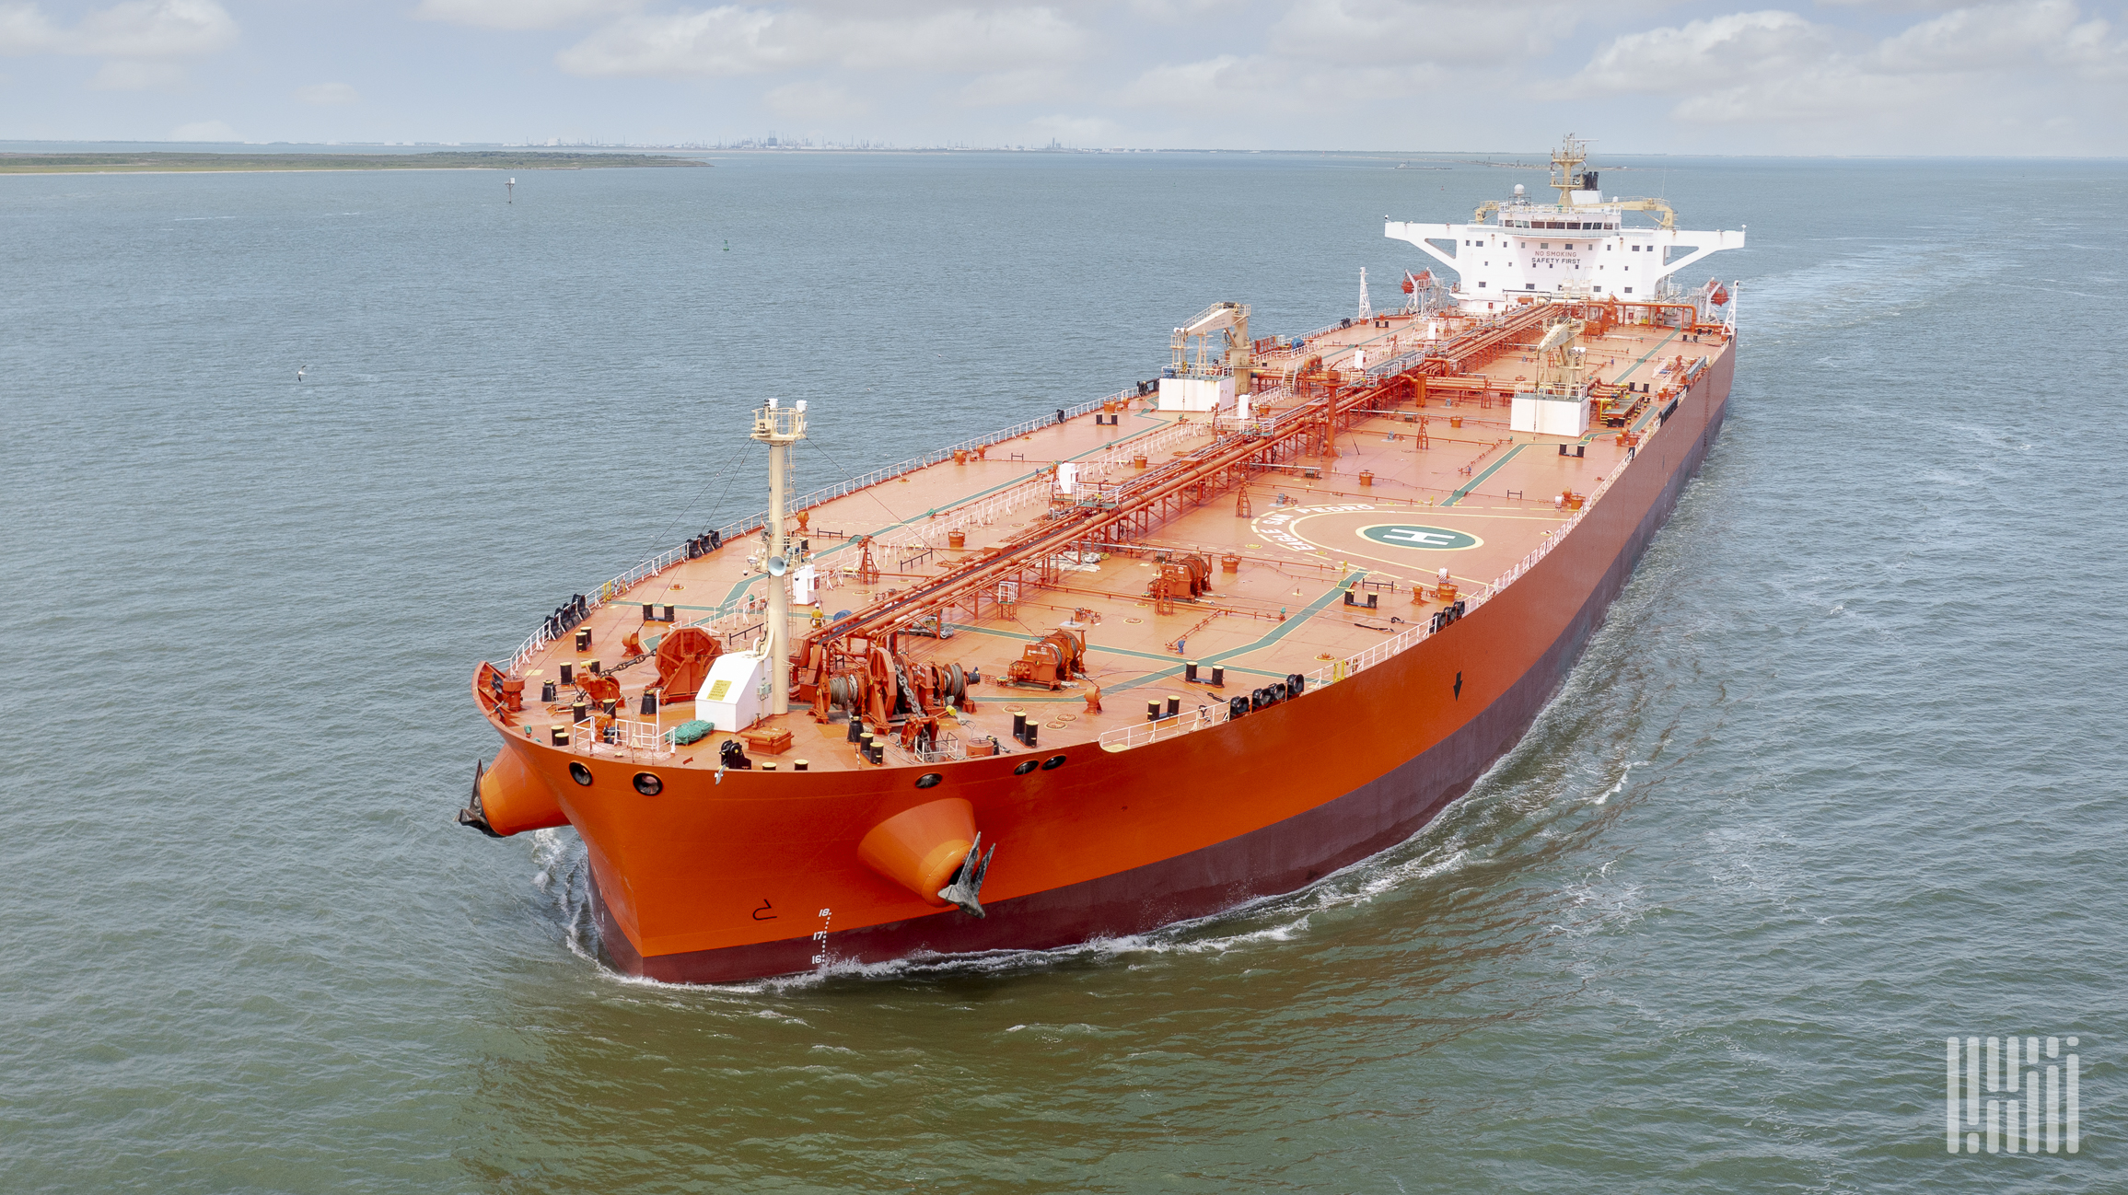

*Picture 1: new tanker builds vs old tanker*

**new**

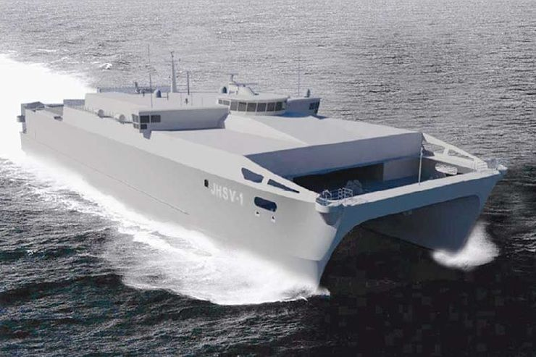

**Old**

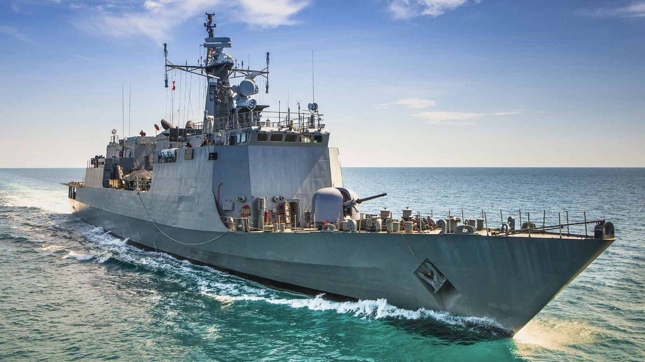

*Picture 2: new military builds vs old military builds*

**new**

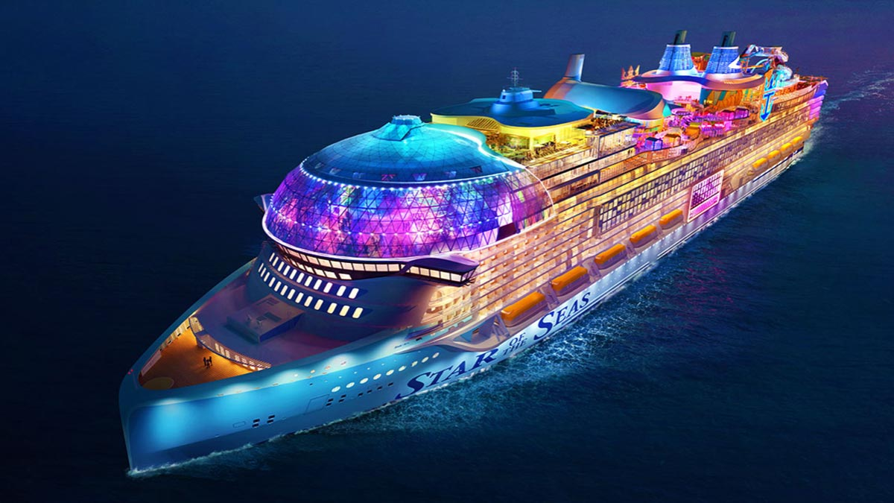

**Old**

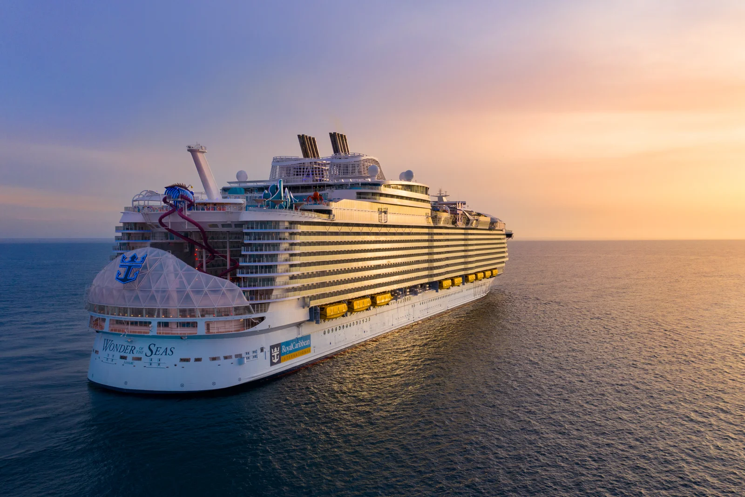

*Picture 3: new cruise builds vs older cruise builds*

**new**

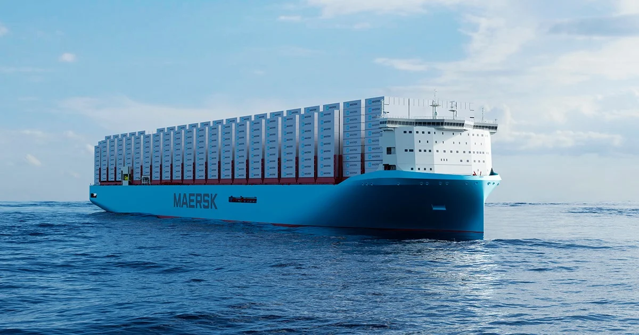

**Old**

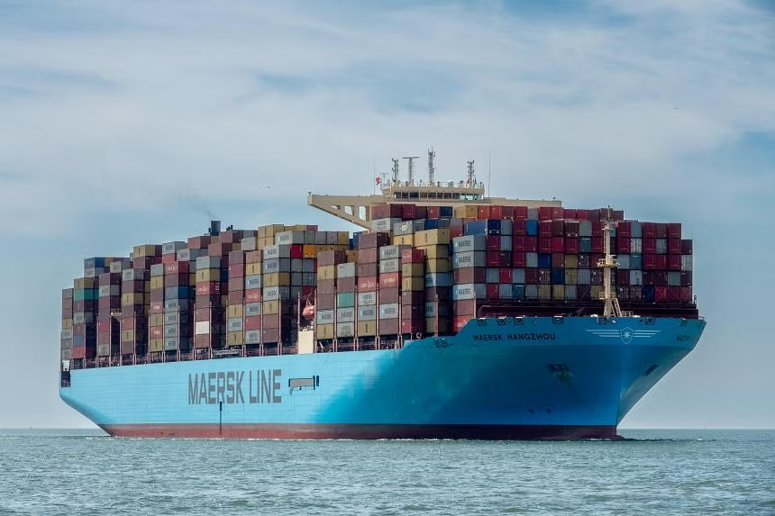

*Picture 4: new cargo builds vs older cargo builds*

**Conclusion**

In conclusion, deep learning will be a useful tool for the maritime industry application to help Singapore’s drive itself as a maritime hub. However, as we discussed from the challenges of a more diversed looking vessel type from multi-fuel transition, deep learning models might need to take more time to tap on more images of new build vessels to eventually predict vessel types more accurately in today’s modern maritime landscape.

**Appendices & References**

appendix 1: [Game of Deep Learning: Ship datasets (kaggle.com)](https://www.kaggle.com/datasets/arpitjain007/game-of-deep-learning-ship-datasets/data)

Appendix 2: [Mission, Vision & Values | Maritime & Port Authority of Singapore (MPA)](https://www.mpa.gov.sg/who-we-are/about-mpa/mission-vision-values)